Figure S1: Illustration of three-step matching algorithm
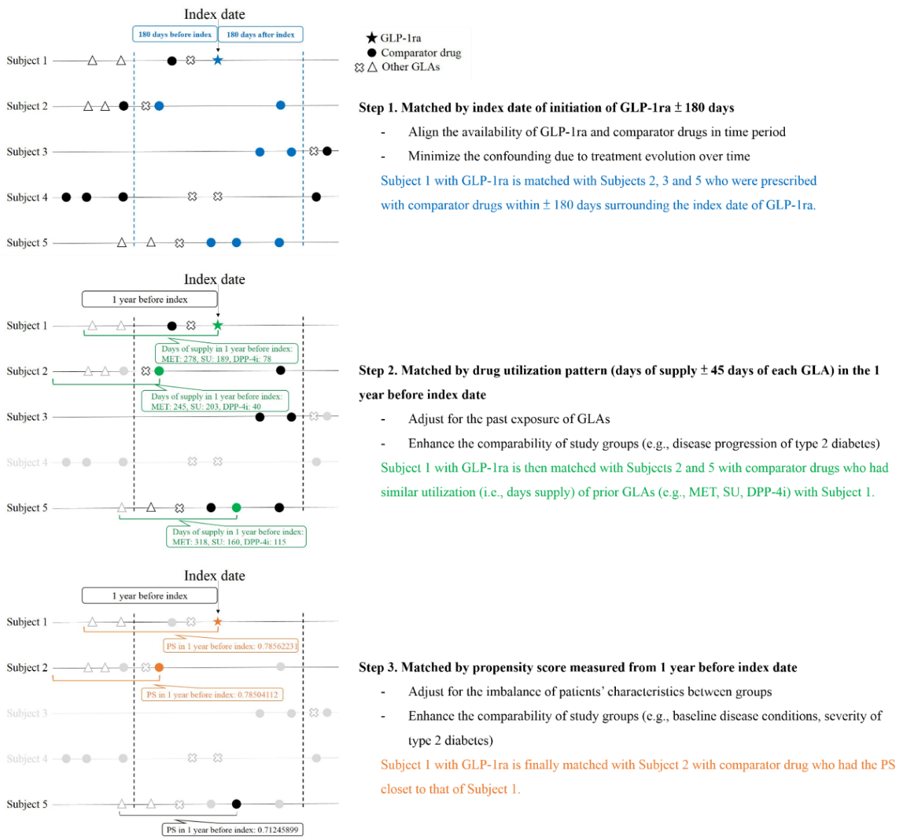
Abbreviations: GLP-1ra, glucagon-like peptide-1 receptor agonist; GLA, glucose-lowering agent; MET, metformin; SU, sulfonylurea; DPP-4i, dipeptidyl peptidase-4 inhibitor; PS, propensity score.

